Shabbos Stories for
Parshas mikeitz 5783
Volume 14, Issue 15 – 30 Kislev 5783/December 23, 2022
Printed L’illuy nishmas Nechama bas R’ Noach, a”h

For a free subscription, please forward your request to keren18@juno.com
Past emails can be found on the website – ShabbosStories.com

Story #1304
A Timely Crossing
Of the River
From the desk of Yerachmiel Tilles
Editor@ascentofsafed.com

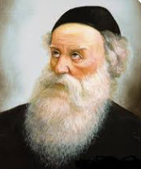

"We will stay here tonight," the Maggid of Mezritch said to his students who accompanied him on his trip. They had stopped at a roadside inn, and requested from the Jewish owner lodgings for the night.
The innkeeper, a G-d fearing Jew, welcomed the party of tzadikim (righteous people) with great joy and honor. He thanked G-d that such a great merit had come his way, to host under his roof holy people like the Maggid and some of his greatest students.
He hurried to arrange a table for his guests laden with all the best food, after which he prepared beds for the whole group. When the guests had finished their meal the innkeeper approached the Maggid and asked to speak to him.
The Maggid agreed and the innkeeper said: "Already for a long time I wanted to come to the Rebbe to ask his advice. I was about to leave for Mezritch and here the Rebbe himself came to my house! Please Rebbe, give me your wise counsel."
After listening to the innkeeper, the Maggid pointed at one of his companions, the youngest of his students, Rabbi Shneur-Zalman of Liadi.

Suggests that the Innkeeper to Ask
Rabbi Shneur-Zalman for Advice
"Please go to him and ask him for his advice," he said to the innkeeper. He added an extraordinary remark, "He has exceptional wisdom, and the soul of the Ramban (Nachmanides, i.e. Rabbi Moshe ben Nachman) [1] lives in him. He will merit a son like me. Do what he tells you."
The middle-aged innkeeper did as he was told by the young tzadik. He approached Rabbi Shneur Zalman and told him what worried him.
For years the inn has afforded him a generous livelihood, since many travelers stop there. He receives them, gives them a place to eat and sleep, and so makes a good profit. Thank G-d, till now the income he made was considerate. Lately though the expenses of operating the inn grew, the rent was raised markedly and, in addition, a heavy tax was put on his earnings. Now he couldn't make ends meet any more.
As a result, added the innkeeper, he thought to leave this inn, with its high rent, and move to a vacant inn on the other side of the river. The cost of running that inn would be less and he would make more profit.

Changing One’s Place Changes One’s Fortune
Rabbi Shneur Zalman heard him out, thought for a while, then agreed to the move to the other inn. He told the man that the move would be for the best, in light of the saying, "Changing one’s place changes one’s fortune -- for good and for blessing."
The innkeeper was glad with these words and Rabbi Shneur Zalman went to his room.
It was early morning, Rabbi Shneur Zalman was in his room, learning Torah. When he left his room he was surprised to see the innkeeper waiting at the entrance. Looking around him Rabbi Shneur Zalman noticed that the inn was completely empty. There was nobody there, nor was there any furniture or any of the other household goods that had been there before.
The innkeeper saw his astonishment and explained: "I heard an explanation of the saying of our Sages '...and take advice from him', that the meaning is that after getting advice from a tzadik one should immediately act upon it, without waiting even one moment. That is why, after I got your advice last night, I right away started to pack all my possessions and transfer them to the other inn across the river."
He added that the Maggid and his other students had already moved to the other inn and they were waiting there for Rabbi Shneur Zalman to join them.
The innkeeper and Rabbi Shneur Zalman left the inn and got into the boat which would take them across the river.

A Sudden Blinding Flash of Lightning
They had hardly stepped into the boat when there was a sudden blinding flash of lightening followed by a tremendous crash of thunder. The lightning struck directly on the inn, which they had left just a few moments before. The lightning strike caused a big fire and in no time the building went up in flames, leaving nothing but a heap of blackened wood and ash.
Everyone was astounded by the Divine Spirit of Rabbi Shneur Zalman and the tremendous faith in tzadikim of the innkeeper, who, by immediately following the advice of the tzadik saved all his possessions from the fire.
The innkeeper merited to live to a great old age. In his later years he heard that Rabbi Shneur Zalman, the author of the Tanya, the six-volume set of Jewish Law known as Shulchan Aruch HaRav, and the founder and Alter (elder) Rebbe of Chabad Chassidism, had passed away. His son, Rabbi Dovber, was his successor and lived in the town of Lubavitch.

The Innkeeper Decides to Travel to Lubavitch
The innkeeper could still hear the voice of the Maggid of Mezritch when he told him that his student the Alter Rebbe would "merit a son like me." He decided to travel to Lubavitch to see the son of the Rebbe.
On entering the room of Rabbi Dovber, the Mittler Rebbe, he was amazed to see how much the Rebbe looked like the Maggid. He knew that the young Rebbe was called Dovber after the Maggid. He was so overcome with emotion on seeing the wondrous likeness between the Maggid and the son of his student that he collapsed in a faint.
This story was told by the grandson of the Alter Rebbe, the Tzemach Tzedek [the 3rd Rebbe], to his son [the Maharash, the 4th Rebbe], so that one should learn from the behavior of this simple innkeeper how to follow the advice of tzadikim.
~~~~~~~~~~~~~~~~~~~
Source: Adapted and supplemented by Yerachmiel Tilles from the first-draft translation by C. R. Benami, long-time editorial assistant for www.AscentOfSafed.com , of an article in the popular Israeli weekly, Sichat Hashavua (#1775).
Connections (5!):
1- Next Monday night (Dec. 12), starts Yud-Tes [19th] Kislev, a Chasidic celebration commemorating the yahrzeit of the Maggid of Mezritch, successor to the Baal Shem Tov;
2 - the miraculous release from Czarist prison of Rabbi Shneur Zalman, the first Chabad rebbe,
3 - and the publication of his magnum opus, Sefer Shel Beinonim (“Tanya” voumel 1).
4 - Also, last Sunday was Yud [10th] Kislev, the anniversary of the liberation of his oldest son and successor, Rabbi Dov-Ber [see the last four paragraphs of the story],
5 - and the preceding day [last Shabbat] Tes [9th] Kislev, was the date of R. Dov-Ber’s birth and of his eventual passing.

Biographical Notes of the Three Great Tzadiks
Biographical notes: Rabbi Dov Ber, [c.1700 - 19 Kislev 1772], known as the Maggid of Mezritch, succeeded his master, the Baal Shem Tov, as the head of the Chasidic movement. Most of the leading chasidic dynasties stem from his disciples and his descendants. The classic anthologies of his teachings are Likutei Amarim and Torah Ohr (combined by Kehas Publishing as Maggid Devorav l'Yaakov), and Ohr HaEmmes.
Rabbi Shneur Zalman [18 Elul 1745-24 Tevet 1812], one of the main disciples of the Maggid of Mezritch, is the founder of the Chabad-Chassidic movement. He is the author of Shulchan Aruch HaRav and Tanya as well as many other major works in both Jewish law and the mystical teachings
Rabbi DovBer Shneuri [9 Kislev 1773 - 9 Kislev 1827] was the eldest son and successor to Rabbi Shneur Zalman, founder of the Chabad movement. The author of numerous deep, mystical texts, he is known in Lubavitch circles as the Mittler (Middle) Rebbe.

[1]Chasidic tradition is that the Baal Shem Tove declared that R. Shneur Zalman was a new soul, never before in a body. I suspect the intention here is ibur, not gilgul (see KabbalaOnline for explanations of these two terms. --y.t.).

Reprinted from the Parshat Vayishlach 5783 email of KabbalaOnline.org is a project of Ascent of Safed.
A Dance of Joy in
Celebration of the Torah

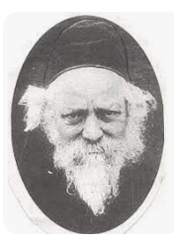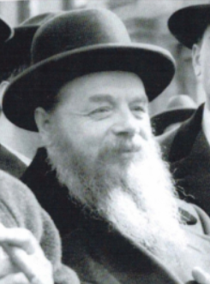
Rav Baruch Ber Leibowitz, zt”l and Rav Shlomo Heiman, zt”l

Rav Shlomo Heiman, zt”l, once came to visit Rav Baruch Ber Leibowitz, zt”l, and found Rav Baruch Ber dancing around the table with some of his Talmidim. As it was an ordinary weekday, Rav Heiman was curious as to why they were dancing.
A Talmid explained to Rav Shlomo that for the past few days, their Rebbe had struggled to understand the meaning of a comment of the Rashba, but he was unable to fully comprehend exactly what the Rashba was trying to say. Then, during a conversation with a student, Rav Baruch Ber was able to understand the Rashba.
He was ecstatic! He was so excited that he grabbed hold of his students’ hands and started dancing around the table. Rav Baruch Ber’s Simchah left a strong impression on Rav Shlomo. He would often say that he was Zocheh to witness Rav Baruch Ber’s joy in Torah knowledge.
No joy in the world could ever compare to the spiritual joy Rav Shlomo had seen on that day. However, it has been taught from this story that the lesson we learn from it is not limited to learning Torah. It extends to any matter that one struggles to achieve a goal. When there are difficult obstacles encountered along the way, one should realize that his success will be far greater, specifically because of all the difficulty he has come across!

Reprinted from the Parshas Vayeishev 5783 email of Rabbi Yehuda Winzelberg’s Torah U’Tefilah.

Trying to Get Admitted to Chachmei Lublin Yeshivah

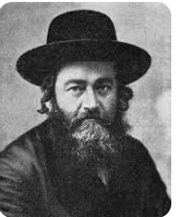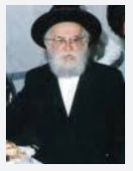
Rav Meir Shapiro, zt”l and Rav Baruch Shimon Schneerson, zt”l

The Tchebiner Rosh Yeshivah, Rav Baruch Shimon Schneerson, zt”l, was a child prodigy, and he was accepted in the top European Yeshivah of Chachmei Lublin, which was run by Rav Meir Shapiro, zt”l. He was a student there for some time.
As a young man, he was selected by the Rosh Yeshivah to be a tester, and test those students who were trying to enter the Yeshivah. The entrance exam included a thorough test on the prospective student’s knowledge of Shas, his analytical skills and intelligence, as well as a complete investigation of his level of Frumkeit, his observance, his Yiras Shamayim, and also, what type of Middos he had.
They sought only the best, and this meant that each student excelled in every aspect of what a true Ben Torah should be. One day, a young man came to the Yeshivah administration, and asked if he would be accepted to the Yeshivah. It was clear that he was a special student, as his Yiras Shamayim and Middos were outstanding.
However, after being tested by the different Roshei Yeshivah, it became clear that he was not the brightest student. His knowledge and understanding of the material were far from exceptional, and his analytical skills were lacking. Unfortunately, this extraordinary young man was not Chachmei Lublin material, and the first group of testers signed off on him with a rejection.

Very Upset About Having to Reject the Student
When Rav Baruch Shimon’s turn to test this student came around, he was very impressed with the young man’s demeanor, his Yiras Shamayim, and his overwhelming desire to learn Torah. But what could he do? The other Roshei Yeshivah had already rejected him. Rav Baruch Shimon was very upset. To him, Yeshivas Chachmei Lublin was founded for the purpose of providing a high standard of Torah education, specifically for such students as this young man.
How could they reject him? He was a unique student with incredible potential. True, he had a long and difficult road ahead of him to achieve this goal, but the passion and the desire were there!
That night, Rav Baruch Shimon could not sleep. He decided to go to the Bais Medrash and spend some time learning. It was two o’clock in the morning, and no one was in the Bais Medrash, or so he thought. He entered the Bais Medrash, and heard a commotion. He was confused. He thought that no one was there.

The Young Man was Weeping Uncontrollable
What was the source of the noise? He looked around and followed the sound of the noise, until he made his way to the back of the building. In the corner, he found the young man who had been rejected earlier that day, weeping uncontrollably. He was repeating over and over to himself how much he had wanted to attend this Yeshivah, regretted his lack of ability, and he was Davening to Hashem to please help him. He wanted so much to learn Torah in Yeshivas Chachmei Lublin!
Rav Baruch Shimon could no longer contain himself, and he too burst into tears. How could they turn away such a Ben Torah? He decided that although the hour was late, he was going to the home of one of the Rosh Yeshivah whose decision carried great weight, and demand that this Bachur be accepted. He woke up the Rosh Yeshivah, and with great emotion, made his argument about this boy, and asked for the Rosh Yeshivah to please accompany him to the Bais Medrash to see for himself, the Bachur’s yearning and Davening for the opportunity to grow in Torah.
The Rosh Yeshivah went to the Bais Medrash and saw the scene that had captivated and moved Rav Baruch Shimon. His heart melted at the sight of this young man pouring out his heart to Hashem. They very next day, the Roshei Yeshivah had a meeting and decided to accept this Bachur to the Yeshivah, and he did not let them down. Within a short time, he was counted among the Yeshivah’s outstanding students. Nothing stands in the way of one’s strong desire!

Reprinted from the Parshas Vayeishev 5783 email of Rabbi Yehuda Winzelberg’s Torah U’Tefilah.

In the Midst of a
Howling Wind

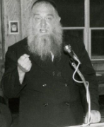

Rav Mottel Weinberg, Rosh Yeshiva of the Yeshiva Gedolah of Montreal, was once seen by a passing driver, standing alone on the outskirts of Boro Park in the midst of a howling wind.
The driver offered to give him a ride. Rav Mottel declined the offer, and replied, "I am trying to convince someone to agree to give his wife a get and he insisted that I meet him out here." Rav Mottel then told the man to quickly drive away so that the hesitant husband would not be frightened off.
Though Rav Mottel zealously defended Kavod HaTorah on numerous occasions, he would sensitively make great sacrifices to protect the honor of an individual. (Torah Luminaries)

Reprinted from the Parshas Vayishlach 5783 email of The Weekly Vort.

A Man of Integrity
By Rabbi Reuven Semah

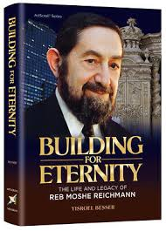

Rabbi Yaakov Bender tells a story about a prominent New York lawyer. The lawyer recalls the day when his firm, one of the finest in the country, signed up a prestigious Canadian client. Olympia and York had just broken into the Manhattan market, and spirits were high in the law firm boardroom as they prepared to welcome the legendary Olympia and York leadership.
Moshe (Paul) Reichman came in, and after introductions and handshakes, he made a short speech to his new team of attorneys.
“In Canada, the government knows that our returns are precise, that we never cut corners. You will be representing us here, so I urge you not to do anything to jeopardize our reputation, even to save money. Our reputation is worth more.”
That was the entire speech, a plea for integrity. It was quiet in the boardroom as the group of hardened, battle-weary lawyers nodded, moved by the unusual request.
A Jew has to go the extra mile. That was the source of Ya’akob’s pain, and we still suffer in the way that we are perceived. Each Jew represents a whole nation and if he takes advantage of a customer or vendor, he just ruined it for hundreds of other Jews.
Once a visibly religious man was driving through the tolls of the Brooklyn Battery Tunnel one morning, racing to the Manhattan hospital where his wife was to give birth. It was in the days before barricades and E-Z Pass, and he could not even stop to pay the toll because his wife was in too much pain.
They reached the hospital, and she gave birth to a healthy baby. Late that night, he went back to Brooklyn, and as he passed through the tunnel, he pulled over and approached the toll booth. He handed the money to the clerk on duty and started to recap what happened that morning. The woman interrupted, “We know, we know. Our colleague told us, and she assured us that you would come back and return it, because that is what you people do…”

Reprinted from the Parshat Vayishlah 5783 email of Rabbi David Bibi’s Shabbat Shalom from Cyberspace. Originally published in the Jersey Shore Torah Bulletin.

The Rambam and
The Blind Child

The Sultan once asked the Rambam (Rabbi Moshe ben Maimon) to heal a child, the son of a close friend, who had been sightless since birth.
“If the child had been struck blind on some occasion after birth, there would have been some hope of my restoring his sight,” the Rambam regretfully explained. “It is, however, impossible to heal one who has been born blind.”
Upon hearing this, the Rambam’s enemies decided to prove his incompetence to the king.
“Your Majesty,” they said, “here is a young man, blind from birth. Maimoni claims it is impossible to heal someone who has never seen. We will heal him.”
The King called for the Rambam and told him to examine the man to see if he was truly blind.
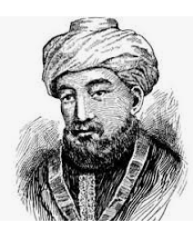

The Silence was Broken by an Exhilarated Cry
The Rambam examined the patient and found him to be sightless. One of the doctors then applied some ointment to his eyes. A few minutes passed in quiet anticipation. The silence was broken by an exhilarated cry from the blind young
man.
“I can see! I can see!”
The Rambam turned to the doctor with admiration in his eyes. “Amazing! A medical miracle!”
To the young man, the Rambam said, “Do you really see? Tell me, what color is this kerchief?”
“Green.”
“And how about this sheet of paper?”
“That’s white.”
“Absolutely unbelievable. I have to see this one more time. What color are the walls?”
“Yellow.”

The Rambam Exposes the Fraud
“Liars! Frauds!” the Rambam shouted. “This man was not blind from birth! Almost anything can be described to a blind man, but how would he recognize and be able to name a color he never saw before? He knew these colors because he remembered them from before he was struck blind!”
The physicians fell to their feet and admitted to paying the young man to say he was blind from birth. (Brilliant Gems)

Reprinted from the Parshat Vayishlah 5783 email of Rabbi David Bibi’s Shabbat Shalom from Cyberspace. Originally published in the Jersey Shore Torah Bulletin.

A Volcanic Explosion and the Israeli Teenage Torah Scholar

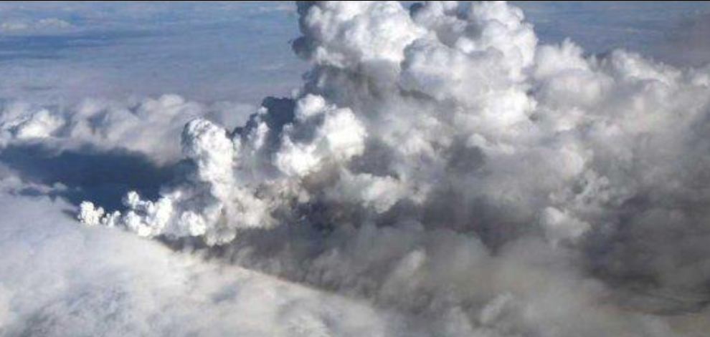
The plumes from the volcanic eruption at Eyjafjallajokull from April 14-20, 2010 that closed major airports all across Europe.

Rabbi Duvi Bensoussan told a story about a Ben Torah who was rewarded for his learning. About ten years ago, there was a 17-year-old boy from Israel who was extremely dedicated to his learning in kollel. He lived and breathed Torah.
One day in 2010, he wasn’t feeling well, so he went home to his mother, who knew he wouldn’t have left the kollel in the middle of the day if it wasn’t urgent. She drove him to the hospital, where they did extensive tests and learned that the boy was in desperate need of a kidney- and not just a regular kidney, but a kidney suited for a teenager.
They told him to go to Belgium, the kidney transplant capital of the world, but warned him that Belgium had a law that priority will be given to European citizens for kidney transplants, ahead of citizens from other countries. If no one on the European list qualified to receive a transplant, due to blood type, location, or some other reason, then they would look at the list of citizens from other countries.
The boy went to his Rosh Yeshivah to ask what he should do, if he should risk going to Belgium knowing he may never receive a kidney. The rabbi looked at his beloved and prized student and said, “Your life revolves around Torah, and Hashem will make the world revolve around you. Go to Belgium. Hashem will give you the perfect kidney.”
The boy flew to Belgium with his father and arrived at the hotel near the hospital to wait for kidney that matched. He was told there were hundreds of European citizens that were on their list, and they would be obligated to go through the entire list of names before reaching his, should a kidney become available. He went to the Belgium kollel to resume his learning.
The next day, an incredible miracle occurred. Huge plumes of volcanic ash coming from an Icelandic volcano at Eyjafjallajokull floated into the air, and every single European flight was grounded. No one was able to fly in all of Europe! It was chaos.
Some kidneys became available for donation, and the hospital began calling the people on the European citizen list to find a match. They called number after number, name after name. No one could fly in to receive the transplant! They finally called this young kollel boy and informed him there was a perfect kidney waiting for him, but he would have to be in town within 24 hours. He went straight from the Belgian kollel to the hospital. The kidney took really well, and this boy’s life was saved!!

Reprinted from the Parashat Vayishlach 5783 email of Jack E. Rahmey as based on the Torah teachings of Rabbi Amram Sananes.

An Eliyahu HaNavi Story
By Rabbi Mordechai Levin

There once lived a wealthy man with a good heart who gave plenty of tzedakah, yet deep down (unfortunately) he felt that the source of his wealth came from his own intelligence and business acumen.
One day, he traveled to town to purchase cattle. He chanced upon Eliyahu HaNavi, who appeared as a merchant. The “merchant” asked him where he was headed. He replied that he was going to the market to buy cattle. Eliyahu replied, “Say ‘Im Yirtzeh Hashem!’”
The man answered, “the money is in my pocket, and it is all up to me.”
Eliyahu said, “If you say so, you won’t succeed.”
A few minutes later, the man’s money purse fell out of his pocket without him realizing it. Eliyahu picked it up and put it on a rock deep in the forest. Sure enough, upon attempting to purchase cattle the man realized that he had lost his money, and he had to return home empty-handed.

The Same Mishap Repeats Itself
A short time after, he took more money and retraced his steps to once again attempt to buy cattle. The same thing happened. Eliyahu appeared this time as an old man and instructed him to say, “Im Yirtze Hashem – If Hashem wants”, the man didn’t listen and fell into a deep sleep.
Eliyahu again took his money and placed it on the rock next to the first moneybag. Upon introspection, the man came to the realization that these punishments had come because he had not heeded the instructions to place his total Emunah in Hashem.
He accepted that from then on, he’d always say Im Yirtzeh Hashem. The third time the man headed to the market, he met Eliyahu who appeared as a poor man. This time he said that he was going “to purchase cattle, Im Yirtzeh Hashem” and was successful.

A Sudden Cattle Stampede into the Forest
Heading home with the cattle, alongside the poor man who chose to accompany him, the cattle suddenly ran off into the forest. He chased them and caught them standing next to a rock, the same rock where his two moneybags were laying,
He thanked Hashem profusely! When he reached home, the poor man disappeared, and he then realized that everything that had happened to him was Hashgachas Hashem (Divine Providence). (Story from the Otzer Midrashim)
Comment: Yosef’s master, Potiphar, realized that “Hashem was with Yosef” (Bereishis 39:3). The Midrash says that Potiphar realized this only because Yosef constantly had the name of Hashem on his lips, always davening to find favor in the eyes of Potiphar. Yosef asked Hashem for everything and anything, and thanked Hashem when his request was fulfilled, and that is why Yosef’s requests were always granted by Hashem.

Reprinted from the Parshas Vayeishev 5783 email of Torah Sweets.

